**Quiz for Java Programming** (Tutor: cyd@bupt.edu.cn)

Unit06-Simple Input and Output

1. Write a program to test if a file exists on your hard disk with the class File. If the file exists, show its size and path.

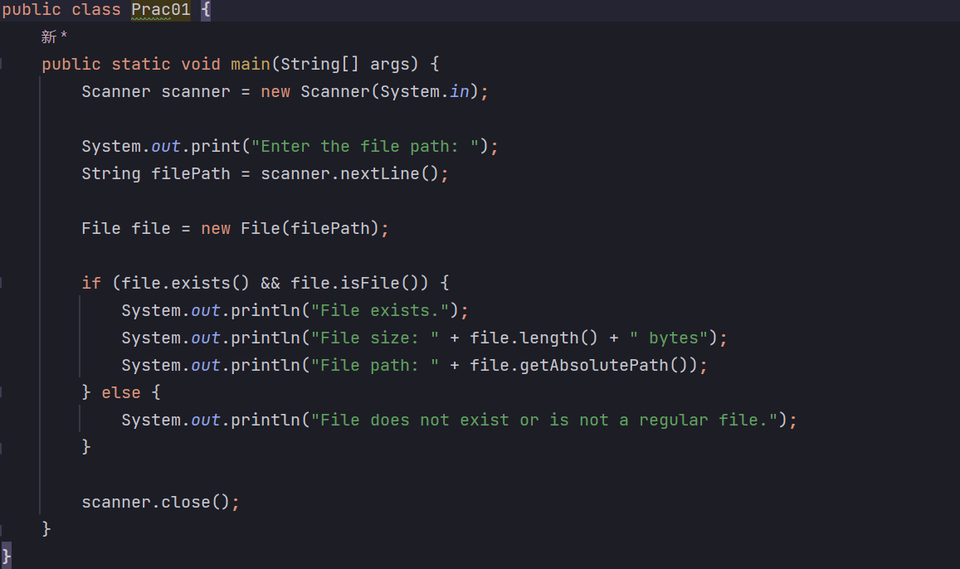



1. Write something into a file1 with FileWriter and file2 with PrintWriter, then read them back with FileReader and show the information.

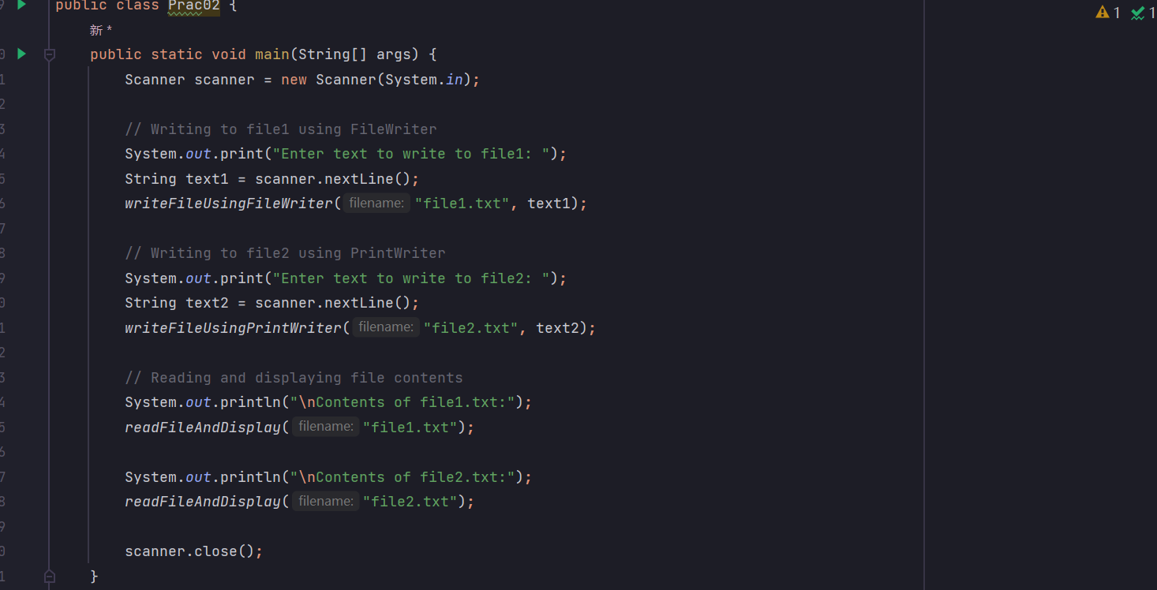

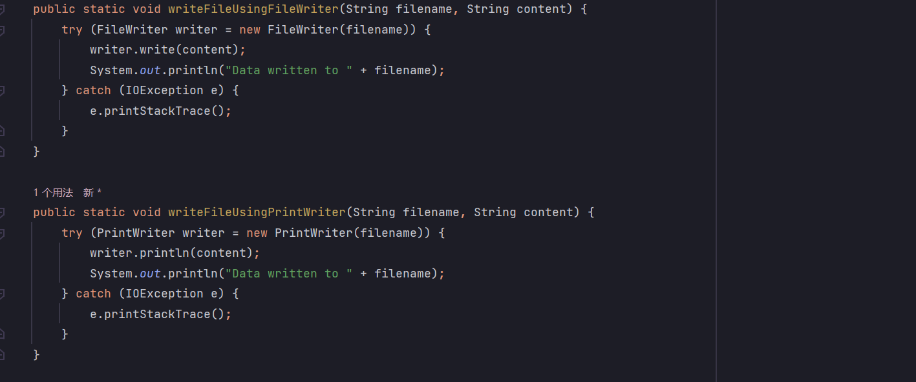

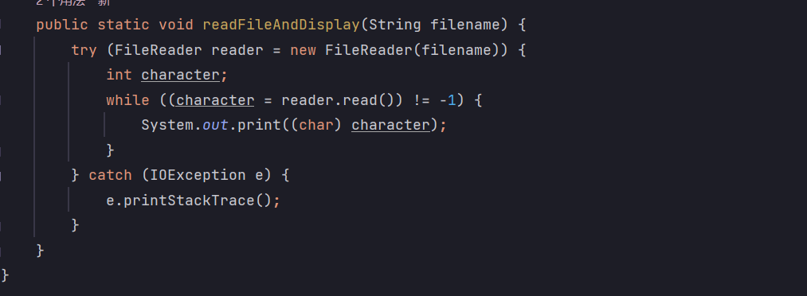

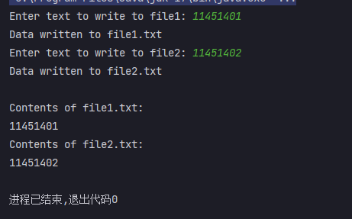

1. Write a program to copy a file with FileOutputStream and FileInputStream. Then modify the program, to use BufferedInputStream and BufferedOutputStream

使用Fos 和Fis

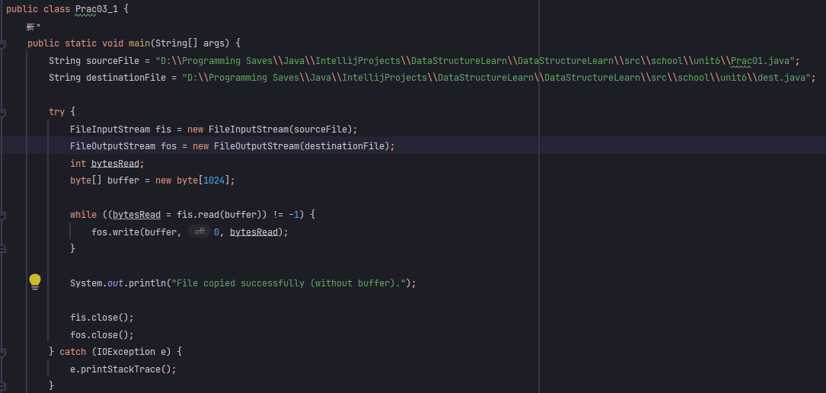

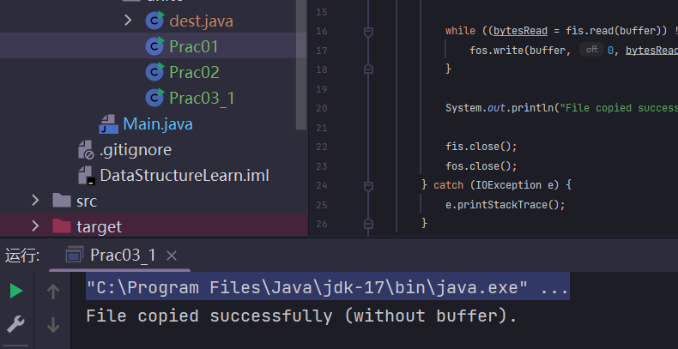

使用 Bis 和 Bos

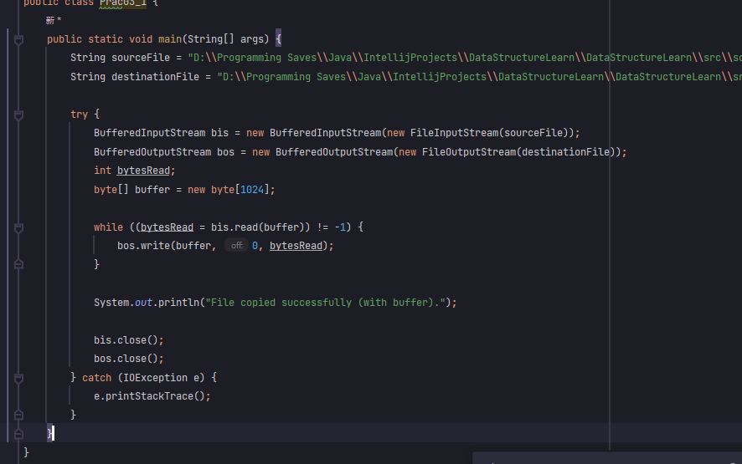

4.Write a program to output an int array to a file with DataOutputStream and then reads them back with DataInputStream and show them.

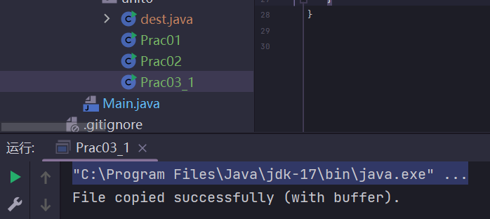

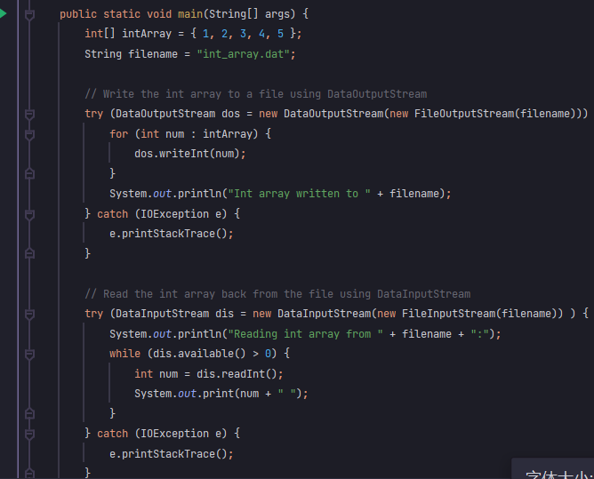

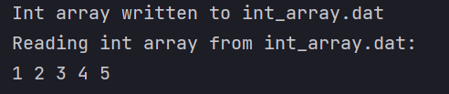

5.Write a program to output a String object and a Integer object to a file and then reads them back.

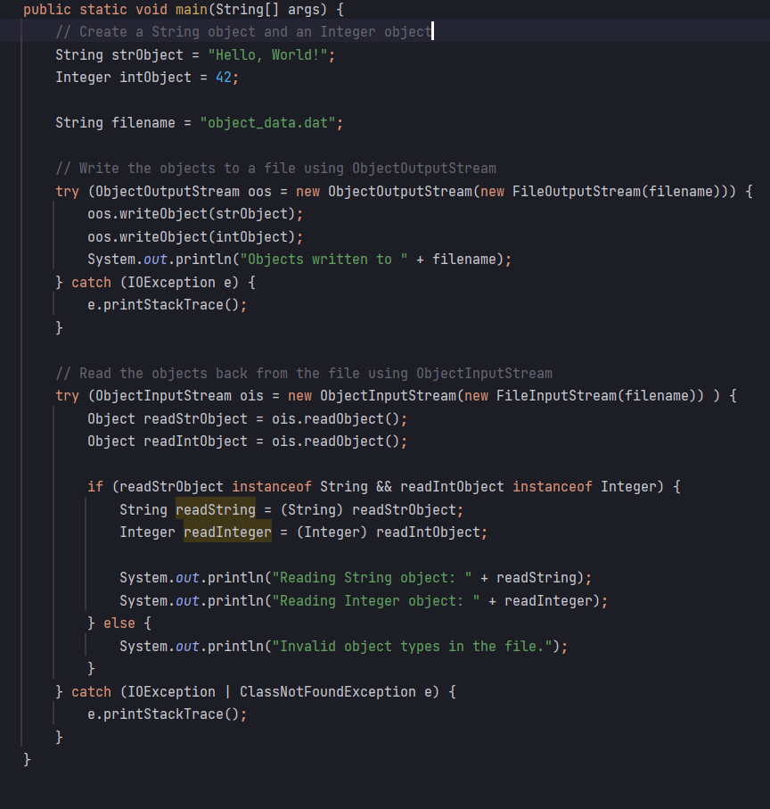

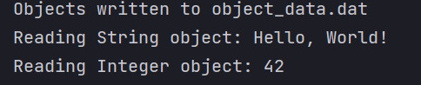

6.Write an integer array to a file with RandomAccessFile and read the last element of the array back from the file.

